⛺️Instructions for the Tabernacle⛺️
Exodus 35 - 36
Remember last week’s lesson?
We learned about the golden calf and how the people of Israel sinned by worshipping a false idol instead of worshipping God.

Today, we will learn the Instructions God gave the Israelites on how to build His house. The Tabernacle, a place for God’s presence to rest and dwell among His people.

🌟TEACHER NOTE: Begin with song! (Speakers will be provided, practice steps before!) After the song, review the 10 commandments and why worshipping idols is sinful.

🗣️Ask: Do you think God stopped loving His people after they sinned?
No! God’s love is so big that even when the Israelites sin He is kind and quick to forgive. After Moses spoke to the Israelites about the sin they committed, many of them repented of worshipping the golden calf.
God spoke to Moses again and said that he wanted a place for His presence to dwell. So, God gave Moses instructions to build a Tabernacle.

What Is the Tabernacle?
The Tabernacle was a special tent where God’s presence would abide and worship ritual happened while traveling through the wilderness. God gave Moses very specific instructions on how to build it because God is holy and perfect.

Exodus 36:1
“‘So, Bezalel, Oholiab, and other skilled craftsmen did as the Lord had commanded Moses.”
God chose special workers to build the Tabernacle carefully and exactly the way He commanded.”

🗣️Ask: Why do you think God gave specific instructions? Do you think God cares about obedience?
Yes! God cares about obedience because He is holy.
Interactive Activity:
🌟 TEACHER NOTE: You will be provided blocks or legos to build a structure. Build a structure beforehand and keep it out of sight of the students. Choose one volunteer. Whisper instructions ONLY to the volunteer in order to build a structure just like yours:
- “Put the red block on top”
- “Add two blue blocks”
- “Put a yellow block beside it”
The class must stay quiet and follow exactly. Then compare it to your original structure.
🗣️Ask: Was it important to follow the instructions carefully? What happened when someone did not listen?
God wanted the Tabernacle built a certain way because it was holy and belonged to Him.

Let’s talk about how God wanted the Tabernacle to be organized. There were three sections in the tabernacle and each section had different elements.
🌟 TEACHER NOTE: You will be given a diagram of the Tabernacle, as you go over each part, have the kids help you place the items in the correct place.
Courtyard: This was the place outside the tents. Here is where the priests would keep the animals used for sacrifices. All the men from the tribe of Levi were allowed here.
- Altar of burnt offerings: The fire would be kept alive to make constant sacrifices to the Lord. It was practiced to have a sacrifice in the morning and in the evening.
- The Bronze Laver: The priest would need to go and wash his hands and feet before making sacrifices or entering the tents.
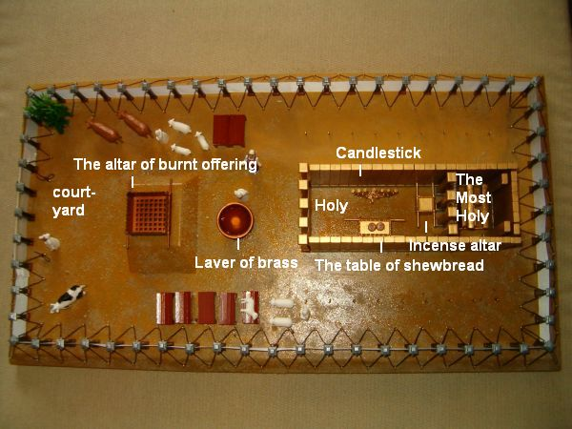
Holy Place:Only the priests could enter this first room of the main tent. They entered daily to perform duties like trimming the lampstand, burning incense, and changing the showbread.
- Menora: it is a lampstand with 7 lampstands to bring light inside the tent. There were no windows inside the tent, so it was very important that the priests keep the fire going. This represents God as holy, pure and the light in the darkness.
- Altar of Showbread: Holding twelve loaves of bread, it represented God's sustaining grace, the twelve tribes of Israel, and the continuous fellowship and covenant between God and His people.
- Altar of Incense: Placed right before the veil of the Holy of Holies, the burning incense represented the prayers and intercession of the people ascending to heaven
Holy of Holies: Only the High Priest could enter this place once a year after performing purification rituals. If a High Priest entered the Holy of holies tent without completing the purification rituals, that priest would die immediately because they were not clean enough to be in the presence of God.
- Arc of the Covenant: Inside the Ark there were three relics: the 10 commandment tablets, a jar of mana, and Aaron’s staff.
The Curtain
In the Tabernacle there was a huge curtain separating the Holy Place and the Holy of Holies because sinful people cannot casually enter God’s holy presence.
When Jesus died on the cross, the temple curtain tore in half! Now through Jesus we can come to God directly and we do not need to do any purification rituals. Jesus’s blood covers us and makes us pure.

Matthew 27:51
“At that moment the curtain in the sanctuary of the Temple was torn in two, from top to bottom.”
🗣️Ask: Who makes a way for us to come near to God?
JESUS!

🎵 Movement Game: “Holy or Not Holy?”
Teacher names something and the students move LEFT if it honors God or move RIGHT if it does not
Examples: Helping others, Worshipping idols, Praying, Lying, Obeying parents, Being selfish, etc.

Big take away from the lesson!
God is holy and perfect. The Tabernacle reminded the Israelites that God wanted to dwell with His people, but sin separates people from God. The Tabernacle pointed forward to Jesus. Jesus came to live among us, die for our sins, and bring us near to God again. We do not need a tent to meet with God anymore because through Jesus we can pray to God and know Him personally.
God wants our worship, obedience, and hearts.

Activity:
- Prayer Time: Lord, thank you for teaching us about the Tabernacle. Thank you because through Jesus, we have direct access to the Father. Help us approach you always when we have a need and help us obey your commands to live in obedience to you. In Jesus' name we pray, Amen.
- Craft: Tabernacle Diagram
- Memory Verse: Have the people of Israel build Me a holy sanctuary so I can live among them. Exodus 25:8

